Q) The objective of this assignment is to simulate the detection and investigation of phishing emails using Microsoft Defender XDR (M365 Defender) integrated with Azure Sentinel. Students will learn how to enable security monitoring, generate test phishing alerts, connect data sources, create detection queries, configure automated analytics rules, and design visual workbooks for incident response. This assignment emphasizes practical application of SIEM (Security Information and Event Management) and SOAR (Security Orchestration, Automation, and Response) capabilities in a Cloud-Native SOC environment.

In this assignment, I am using the Azure free account and the Microsoft 365 Business Premium free trial. I have also enabled the Microsoft Defender for XDR P2 add-on.
I created a dedicated user account and assigned it the Global Administrator role. This single account will be used to perform all user creations and security configurations throughout the assignment.
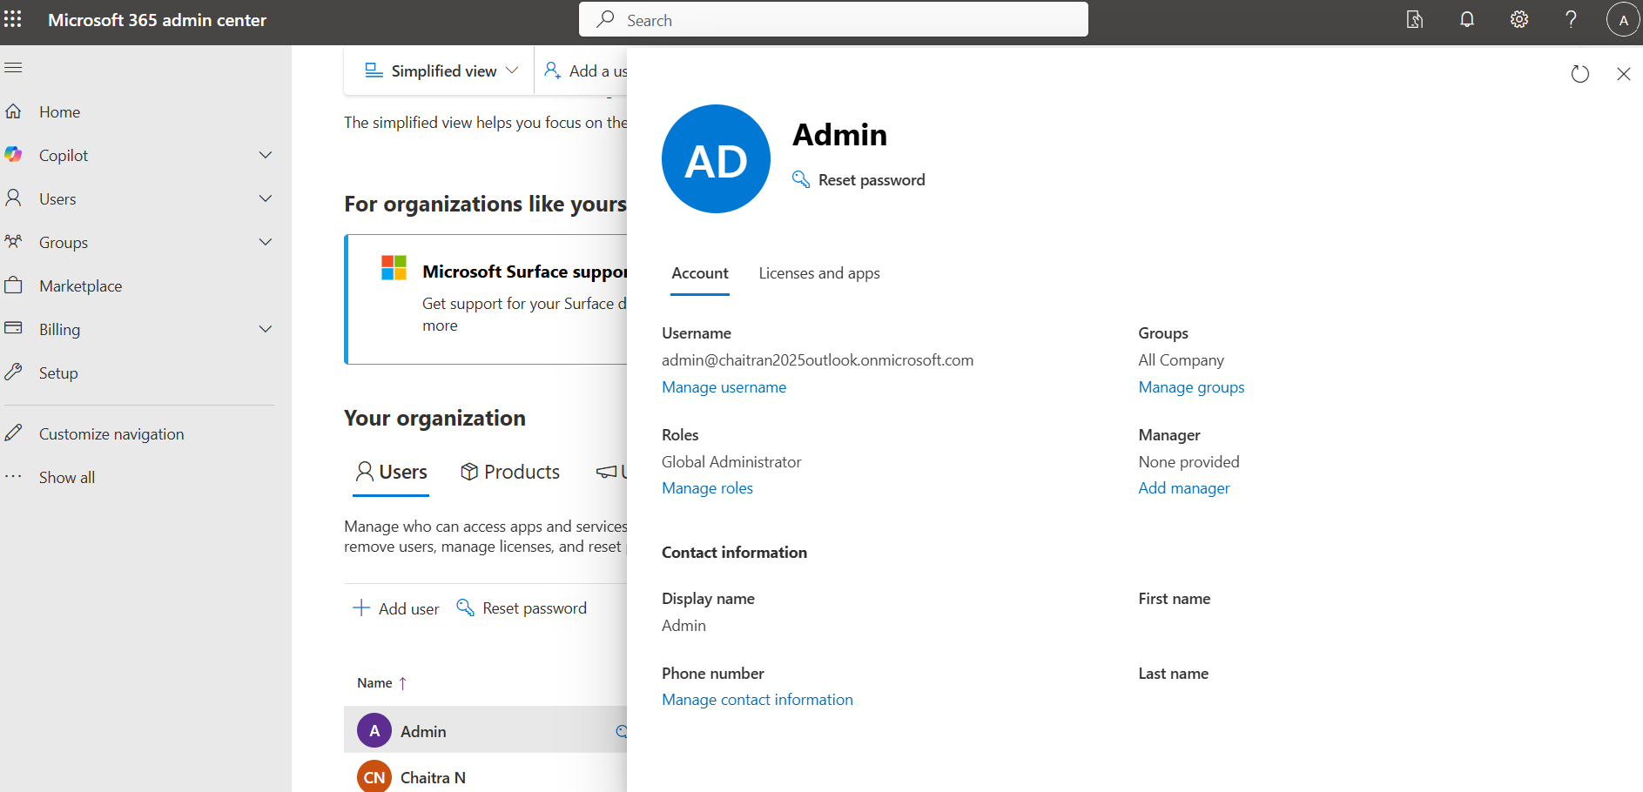
admin@chaitran2025outlook.onmicrosoft.com

After enabling Microsoft Defender, the Incidents and Alerts section became visible in the security portal (security.microsoft.com), confirming that Defender was successfully configured.
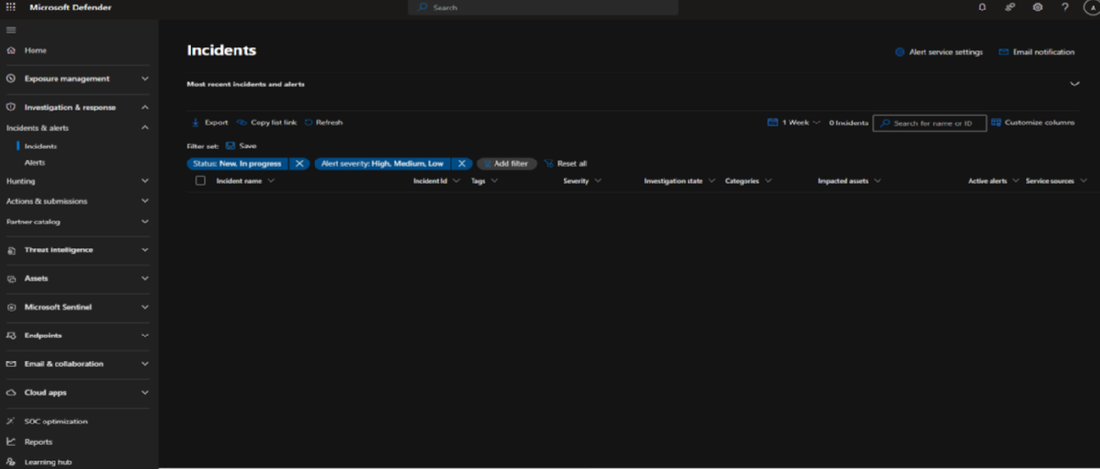
Microsoft Defender was enabled, and the necessary administrative roles were assigned to the admin account to ensure proper access and configuration.
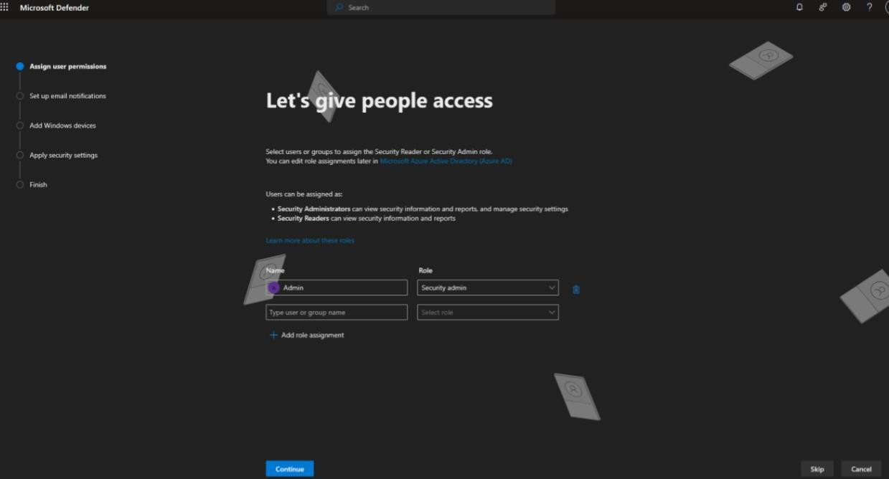

An email notification rule was configured to ensure that security teams are promptly alerted whenever new incidents or threats are detected.
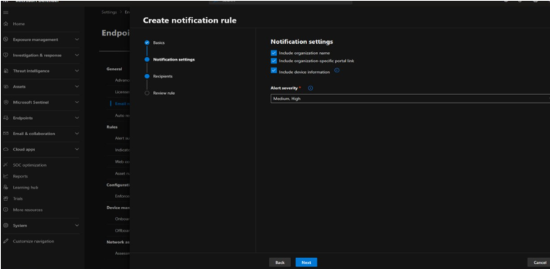

To enable Microsoft Sentinel, a Log Analytics Workspace must first be created. Sentinel itself is a service and cannot function without a data store. Log Analytics serves as both the storage and query engine, and when combined with Sentinel, they together form a complete SIEM solution.
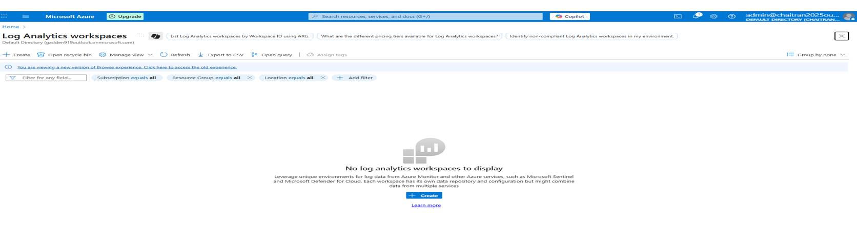

A Log Analytics workspace was created and named SOC-LAB to serve as the central data store for Sentinel.
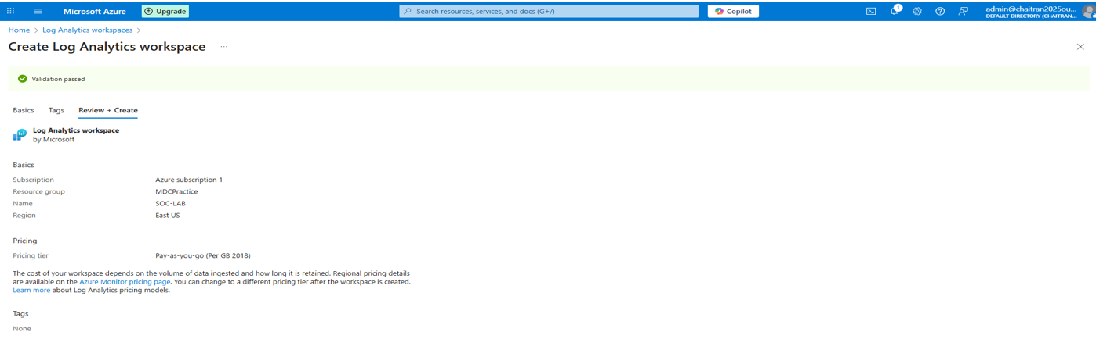

The next step was to connect Microsoft Sentinel with Microsoft Defender. This required linking the previously created Log Analytics workspace to Sentinel, enabling Defender data to be ingested and analyzed.

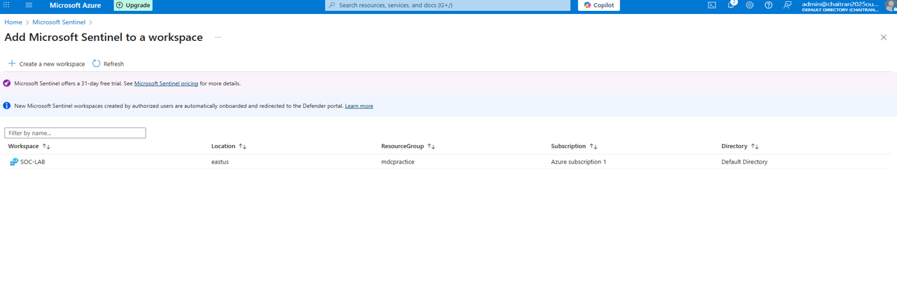

The Log Analytics workspace was successfully added to the Microsoft Sentinel environment, completing the integration setup.
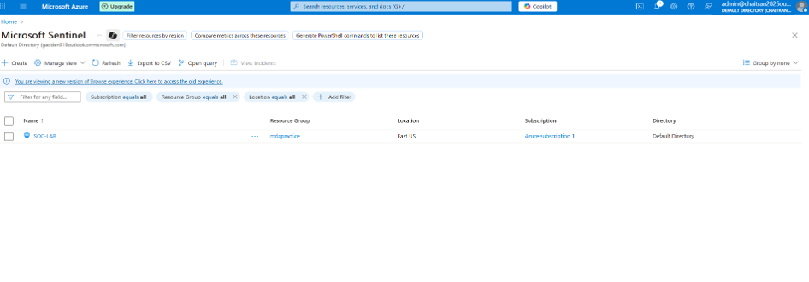
Next, the required content was installed from Content Management, followed by connecting the necessary data connectors through either the Sentinel portal or the Defender XDR page.

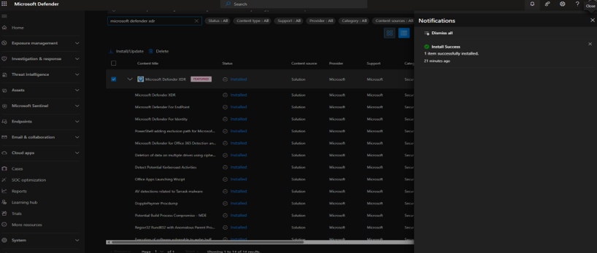

The Microsoft Defender XDR content was successfully installed.

The next step involved connecting the data connectors to ensure that security incidents and alerts could flow into Microsoft Sentinel for analysis.
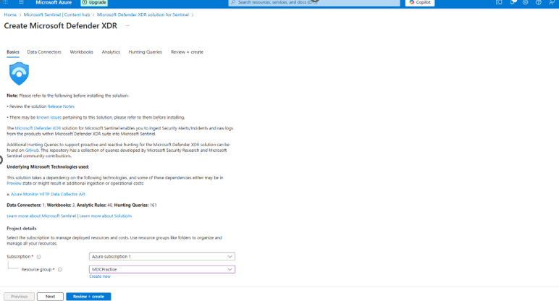

The data connectors for Microsoft Defender XDR were successfully deployed, enabling the integration of Defender alerts and incidents into Sentinel.

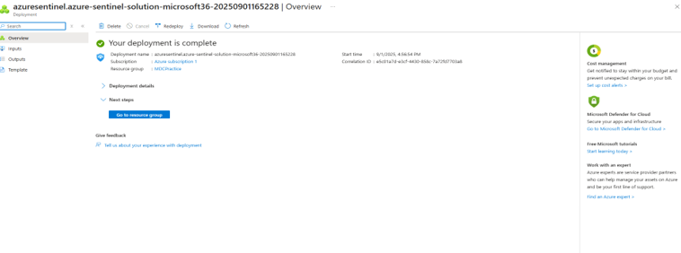
The connector status was verified, and it showed as connected, confirming successful integration.

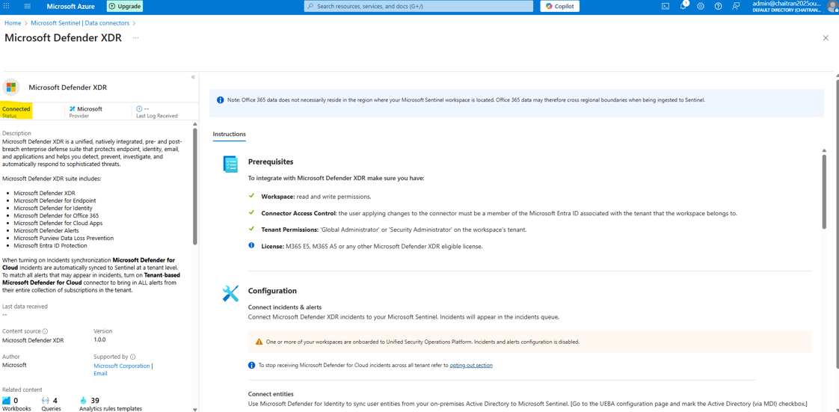

To verify the KQL configuration, a sample query was executed. However, no events were found in Defender at that point.
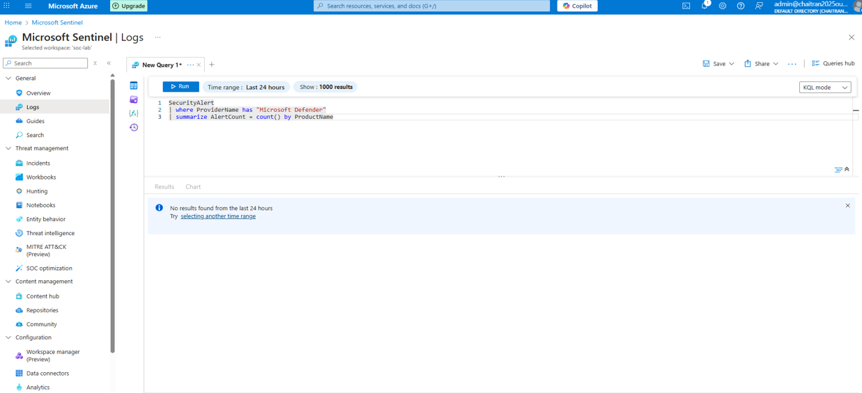

For auditing purposes, Microsoft Purview was configured and linked with the Azure account. This enabled the recording of both user and administrator activities. 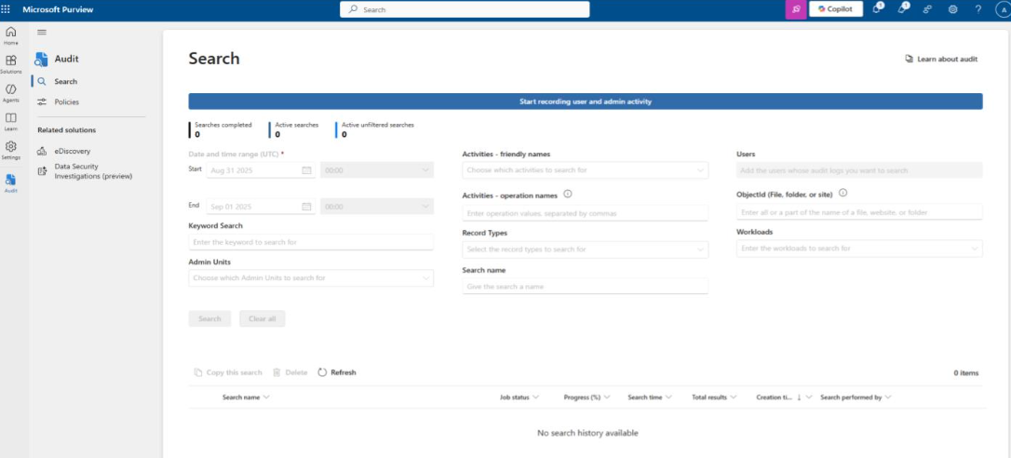

A phishing email simulation was initiated using the Attack Simulation Training feature in Microsoft Defender to test user response and system detection capabilities. 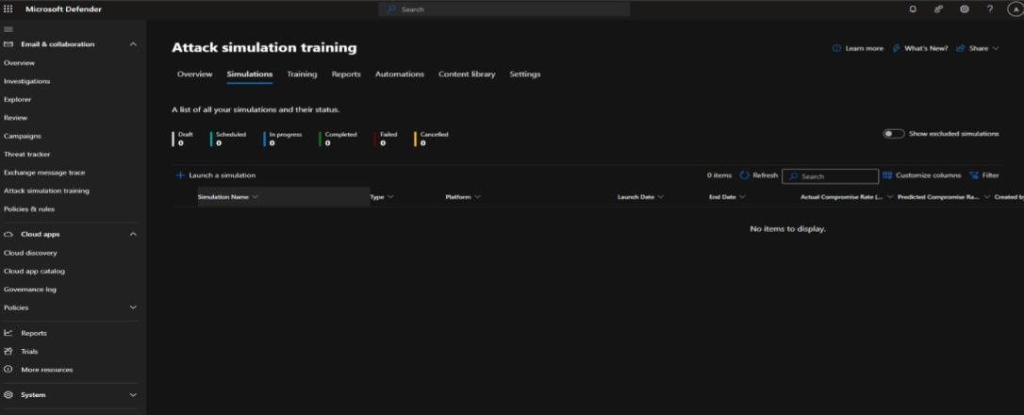

The Credential Harvest technique was selected for the phishing simulation, as it is commonly used by attackers to trick users into revealing their login credentials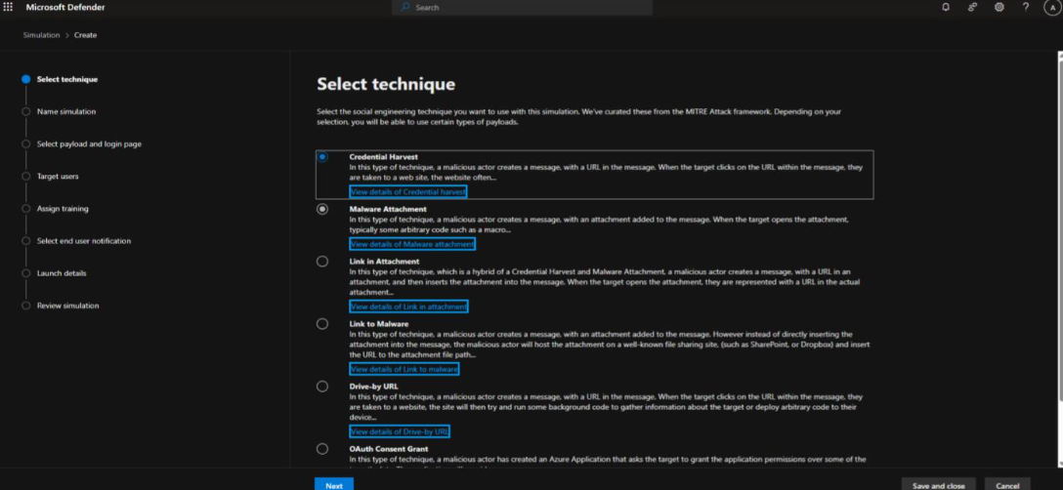

Payload was selected for the phishing simulation to deliver the attack scenario to the targeted user. 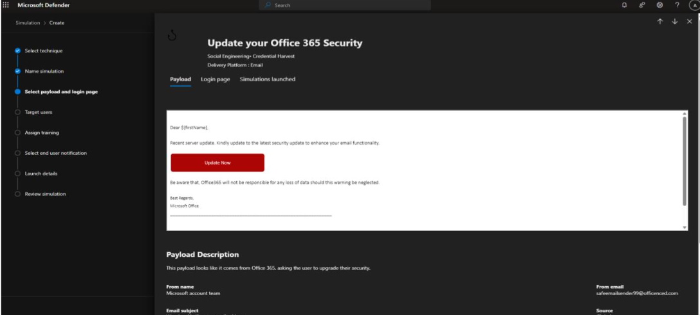

All available users were selected as targets for this phishing simulation test.” 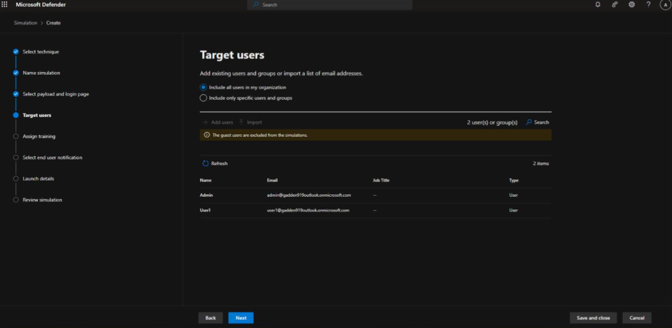

After filling in the required configuration details, the phishing simulation was launched. 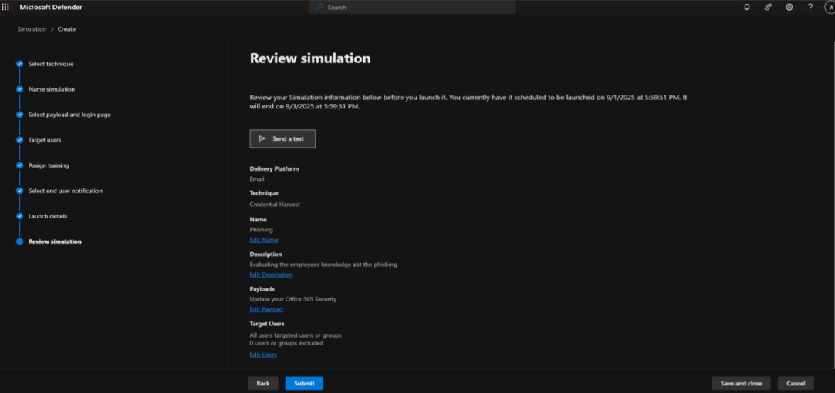

The phishing simulation was successfully completed, confirming that the configuration and execution steps were carried out correctly. 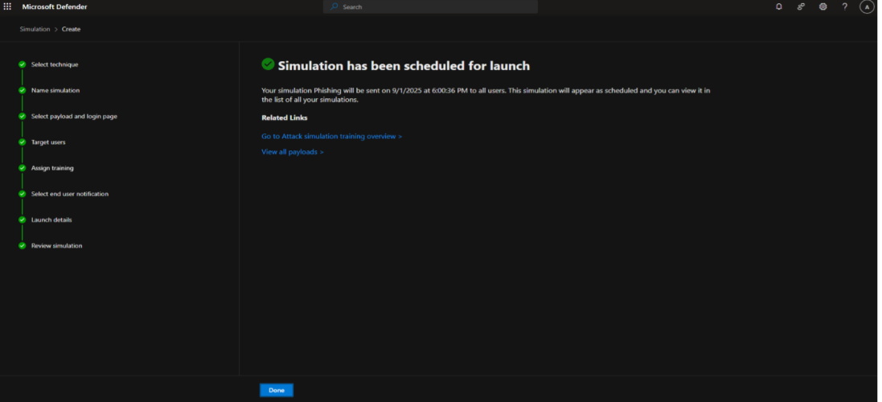
Upon logging into the user account, the simulated phishing email was successfully received in the mailbox.

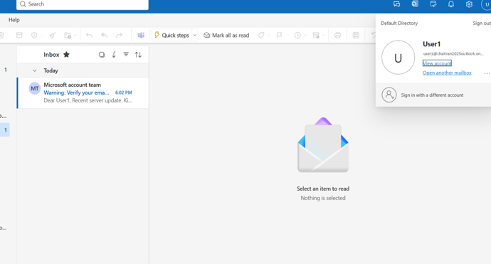

The phishing email link was opened, and credentials were entered to simulate a real-world phishing scenario.
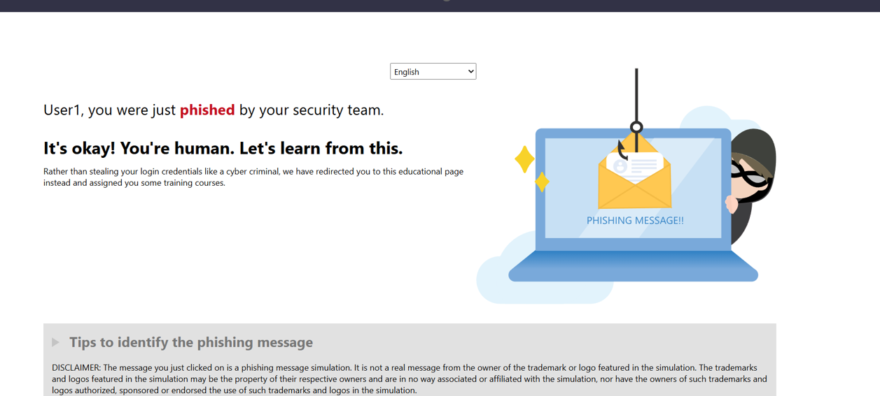
Since the phishing incident was not reported in Defender during the initial test, an Anti-Phishing policy was created to strengthen detection and ensure such attempts are properly identified. 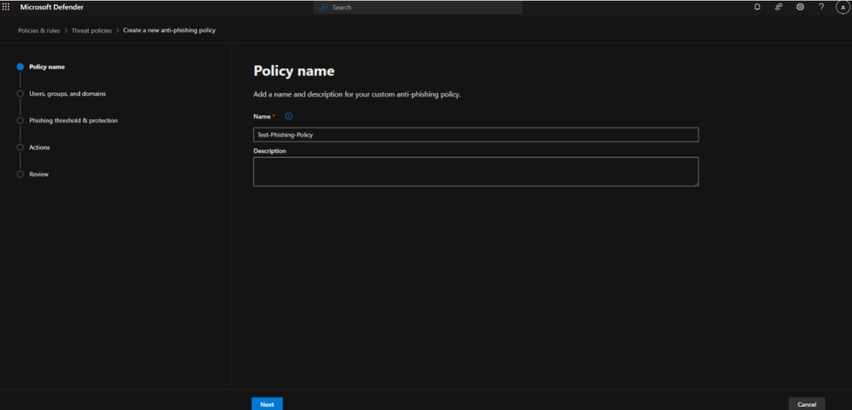

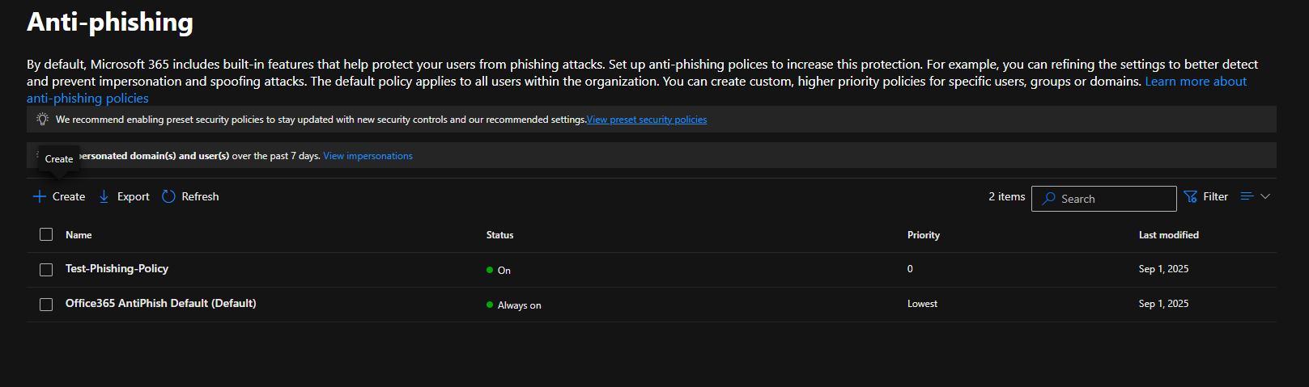

After configuring the Anti-Phishing policy, the phishing simulation was executed again, and this time an alert was successfully generated by Microsoft Defender XDR.

An endpoint device was also onboarded, and a malware simulation was executed. The activity was successfully detected and reported in Microsoft Defender XDR also the phishing alerts were captured.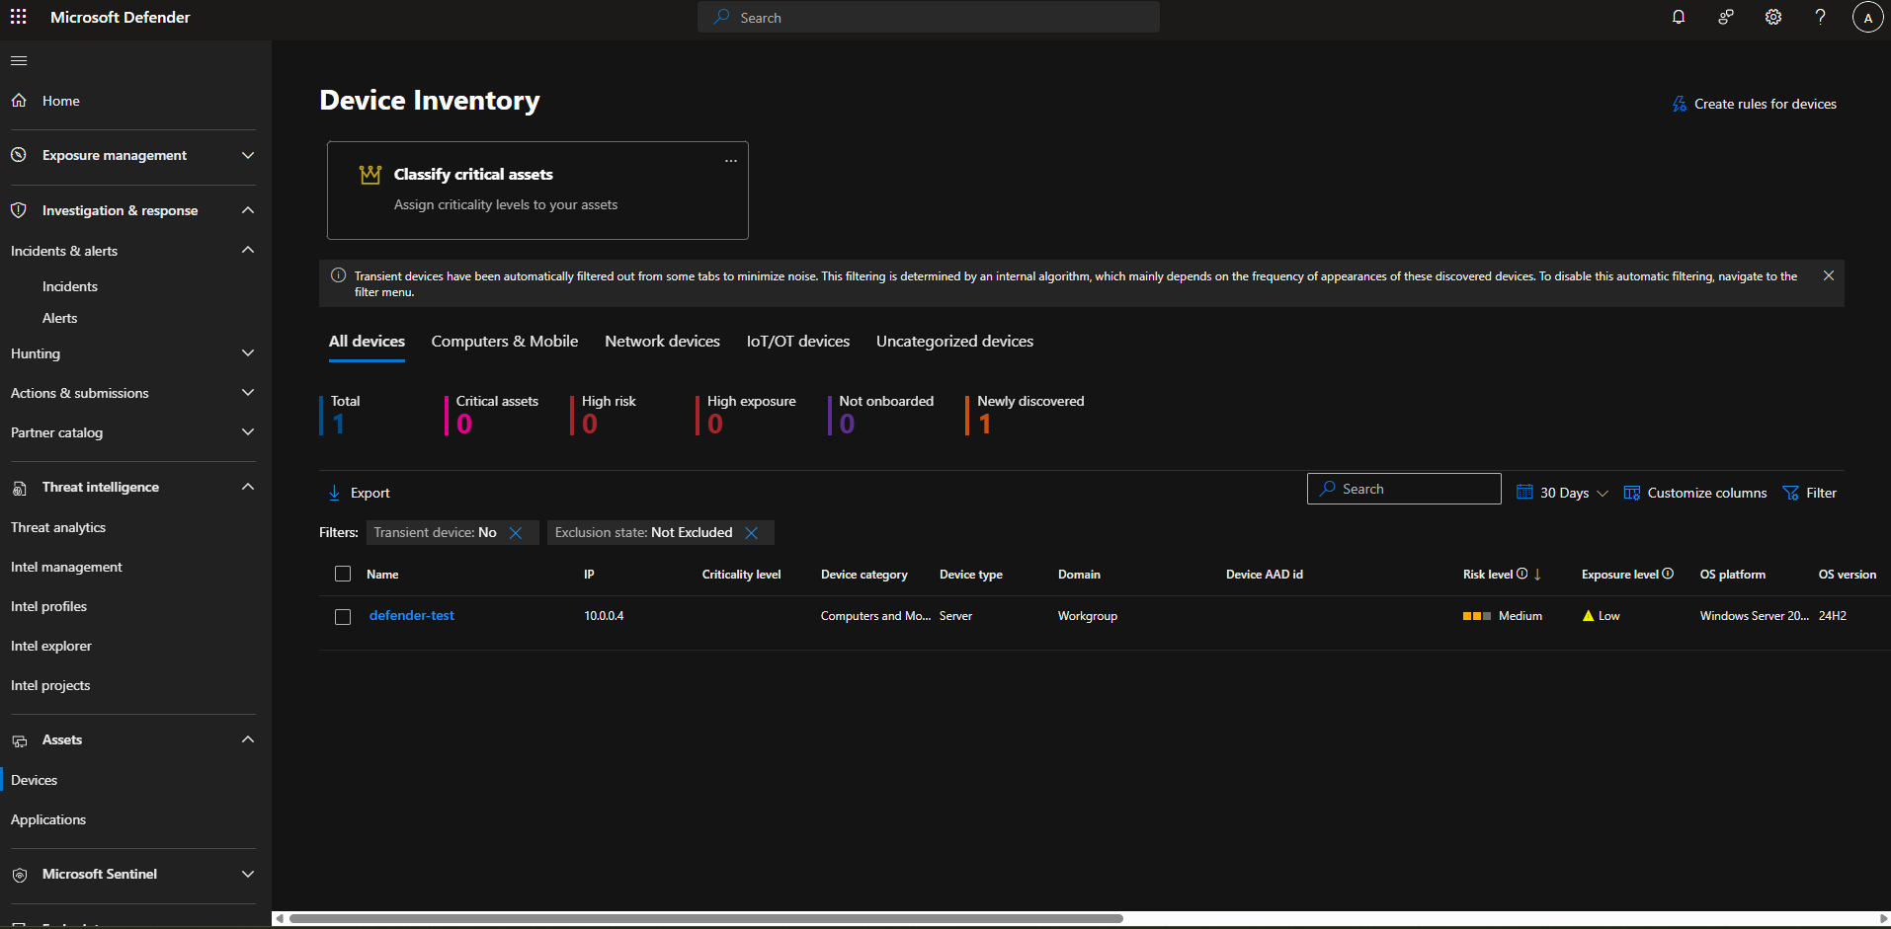

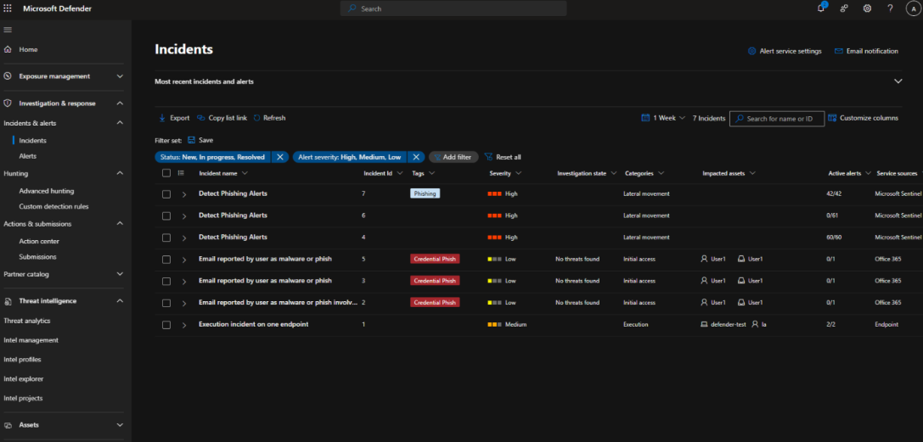

The alerts were also verified in Microsoft Sentinel, confirming that the configuration was successful and that incidents from Defender XDR are syncing properly into Sentinel.

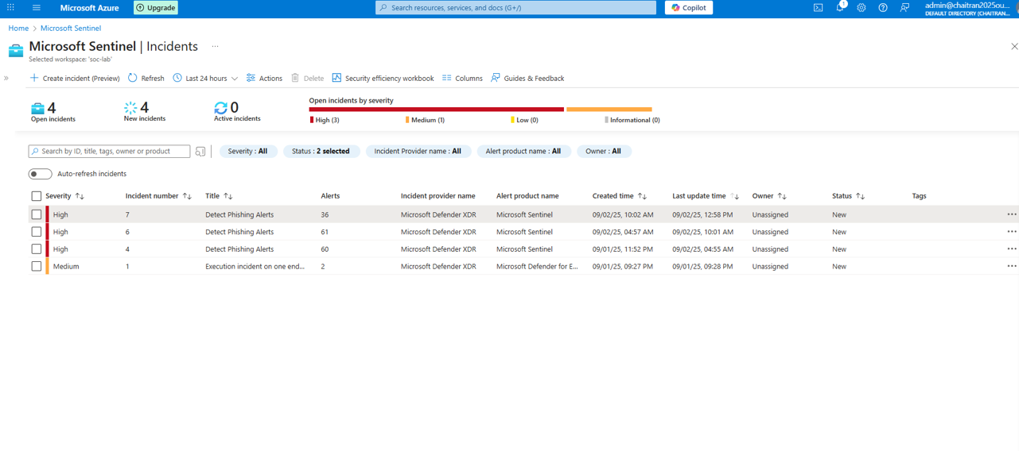

The generated alerts were queried and verified using KQL (Kusto Query Language) in Microsoft Sentinel, ensuring that the data ingestion and detection logic were functioning as expected.
SecurityAlert
| where DisplayName has "Phish" // But was later identified as Phish
| summarize Incidents=count() by bin(TimeGenerated, 1m)
| order by TimeGenerated desc

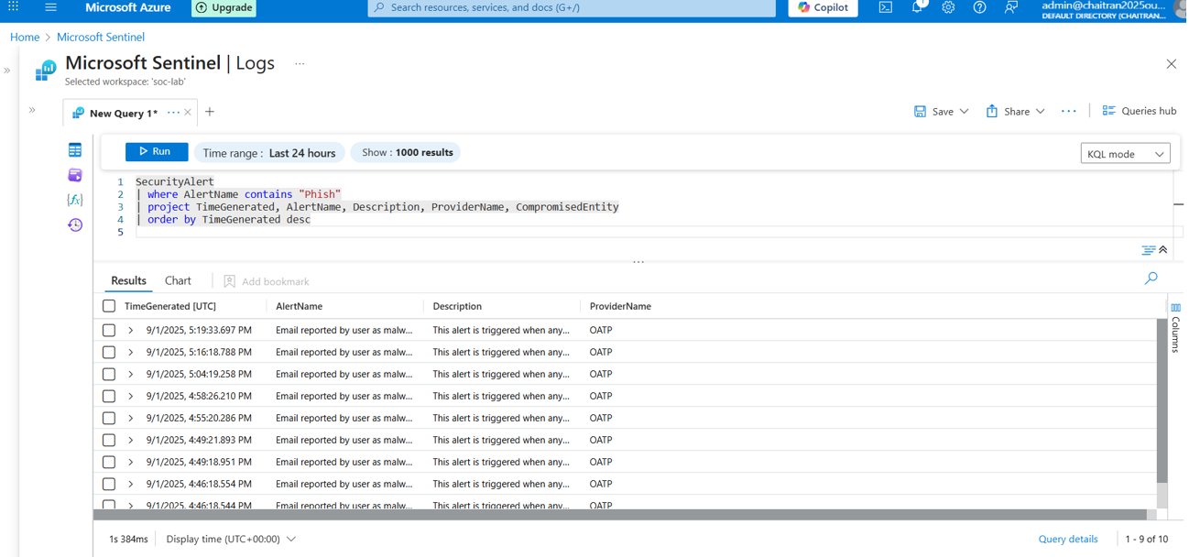

EmailEvents
| where DeliveryAction == "Delivered" // It got through initially
| project Timestamp, Subject, SenderFromAddress, RecipientEmailAddress, DeliveryAction
| take 10

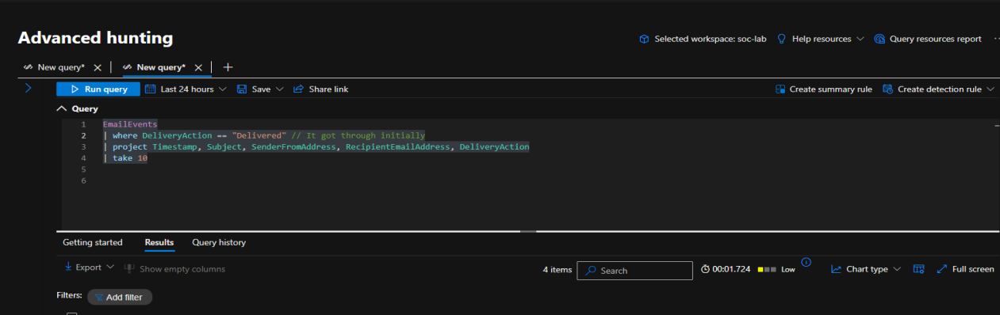

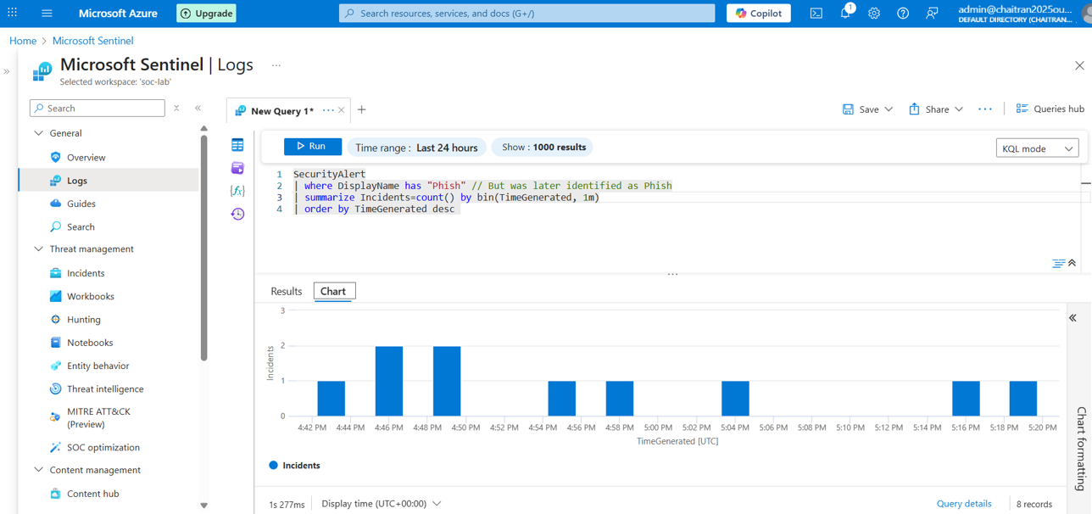

Analytics rules were created in Microsoft Sentinel for phishing detection. The required fields specific to phishing incidents were selected to ensure accurate rule configuration and automated alert generation

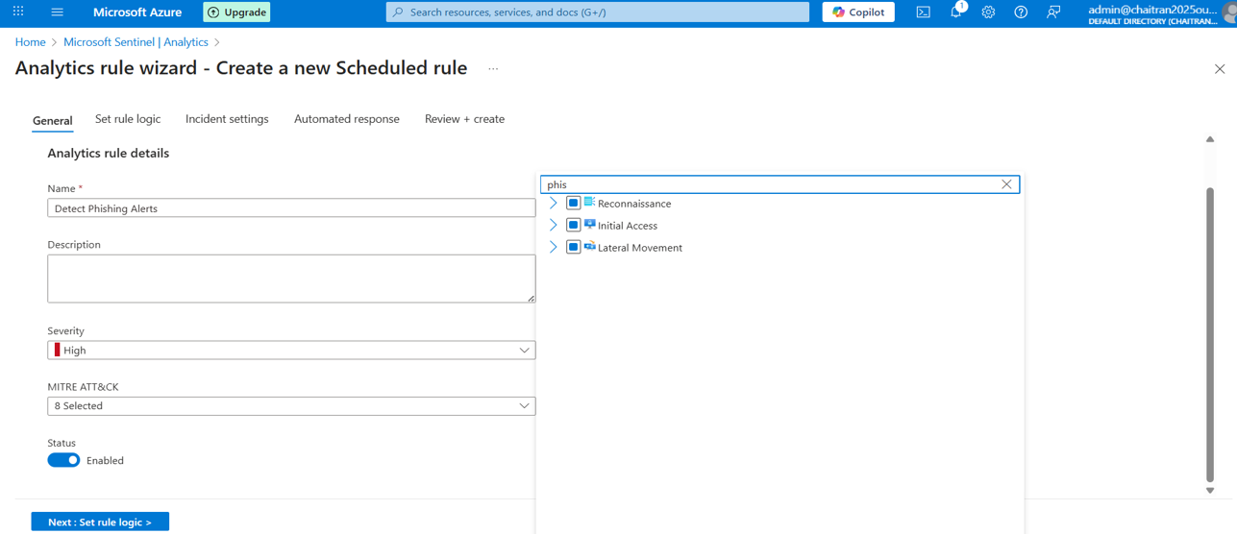

The detection logic was configured within the analytics rule and tested against the available data to validate its accuracy and effectiveness.
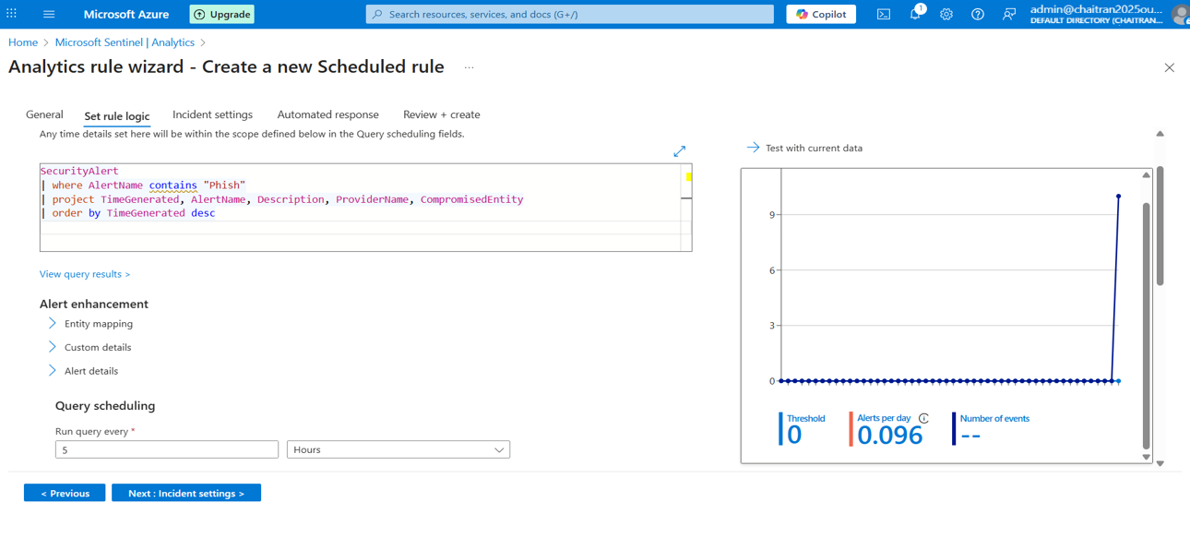

This represents the overall configuration of the analytics rule, defining how phishing-related alerts are detected, processed, and escalated within Sentinel.
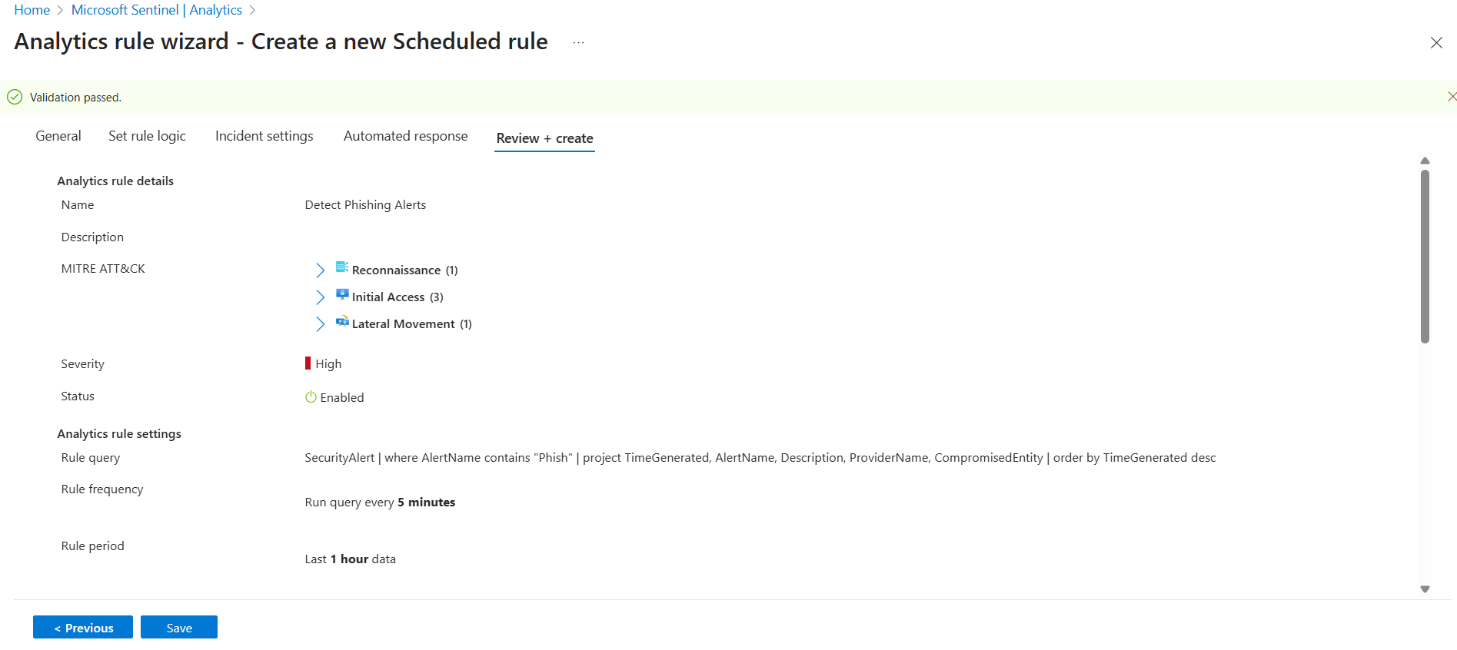

The analytics rule was successfully created, enabling automated detection and incident generation for phishing alerts in Sentinel.
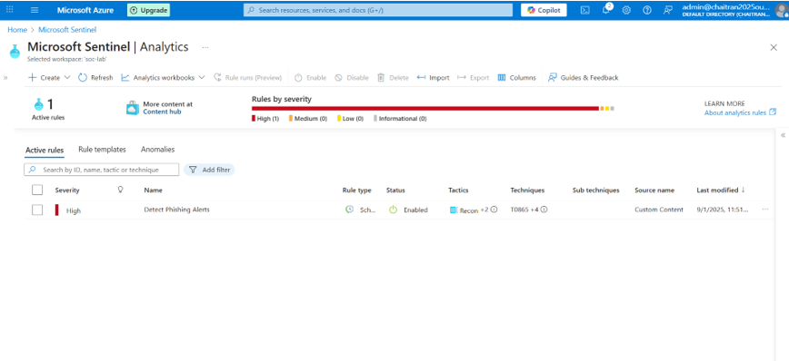

Another phishing email was generated to test the effectiveness of the analytics rule. The alert was successfully triggered and reflected in both Microsoft Defender and Sentinel, confirming that the rule was working as intended.

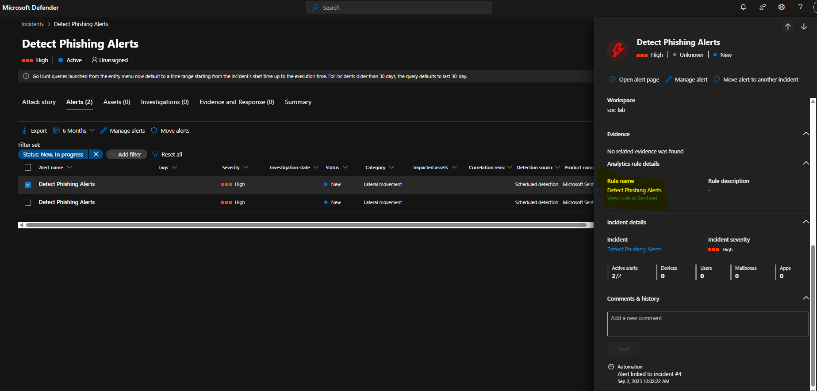

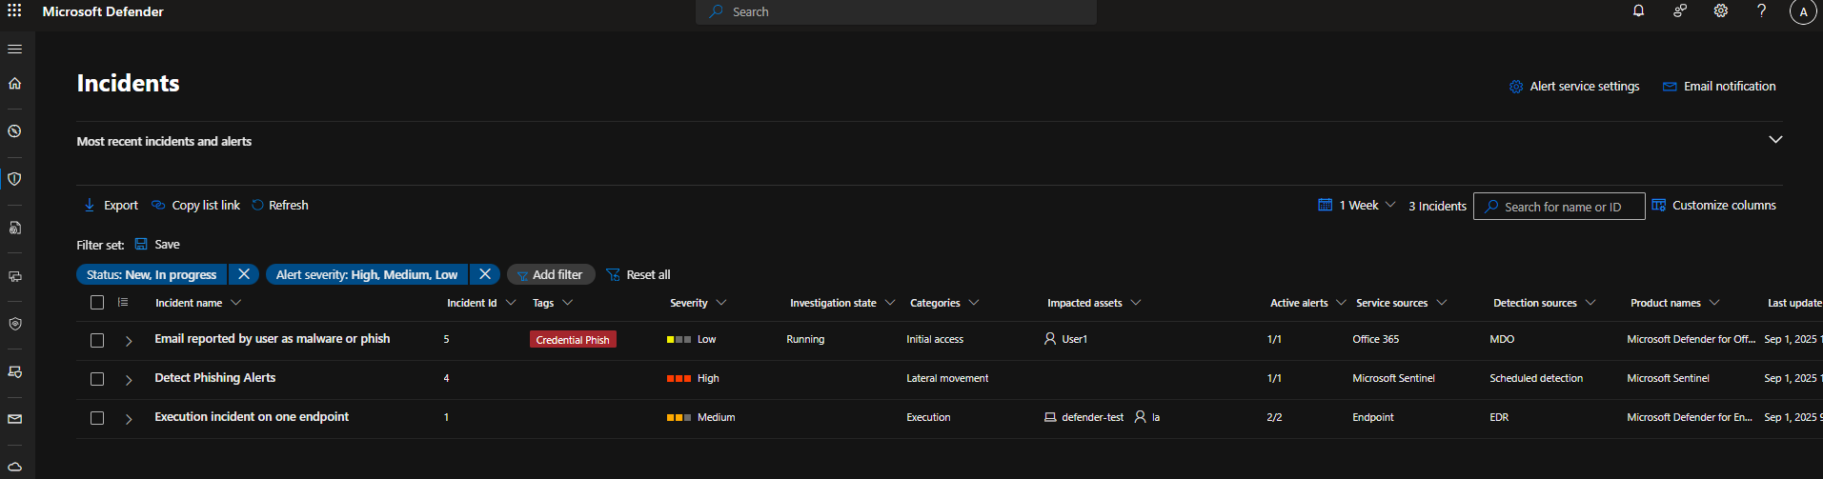

The incidents were also verified in Microsoft Sentinel, confirming that the alerts originated from the configured analytics rule. This validated that the analytics setup was working correctly.

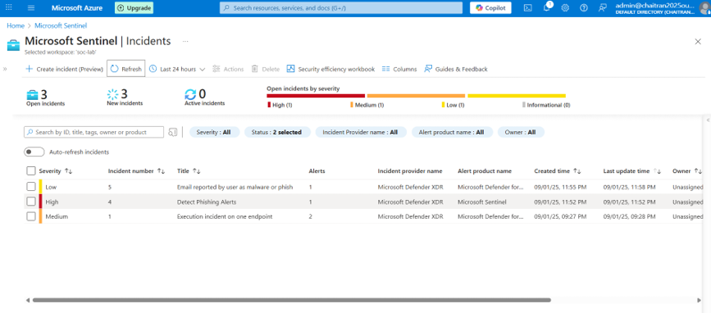

The Analytics performance section in Sentinel also displayed the alert generated by the configured rule, further confirming that the analytics rule was functioning as expected.

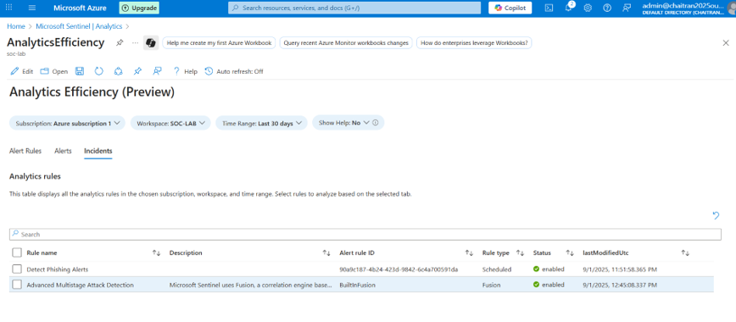
Workbook is created in the Sentinel work space
Bar Chart: Top Phishing Alerts
// Shows top 10 phishing alerts grouped by alert name and provider
SecurityAlert
| where AlertName contains "Phish" // Only take alerts where the name contains the word "Phish"
| summarize PhishingAlerts = count() by AlertName, ProviderName // Count the number of phishing alerts, grouped by AlertName and ProviderName
| top 10 by PhishingAlerts desc // Take only the top 10 results, ordered by the number of phishing alerts
| project Campaign = strcat(AlertName, " - ", ProviderName), PhishingAlerts // Create a new column called Campaign by joining AlertName and ProviderName
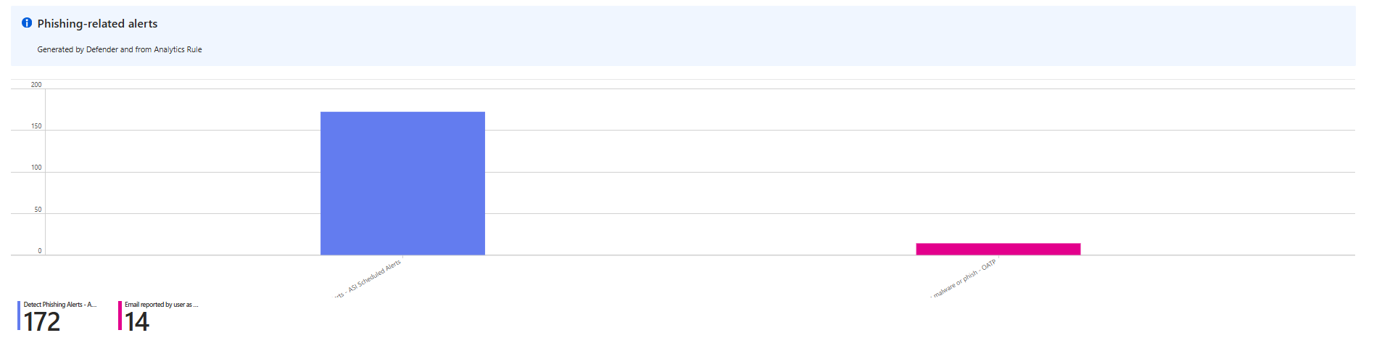

Phishing Alerts Over Time
// Look inside the SecurityAlert table
SecurityAlert
| where AlertName contains "Phish" // Only take alerts where the name contains the word "Phish"
| summarize PhishingAlerts = count() by bin(TimeGenerated, 1h) // Count phishing alerts grouped into 1-hour time buckets
| order by TimeGenerated desc // Order the results by time, with the most recent first
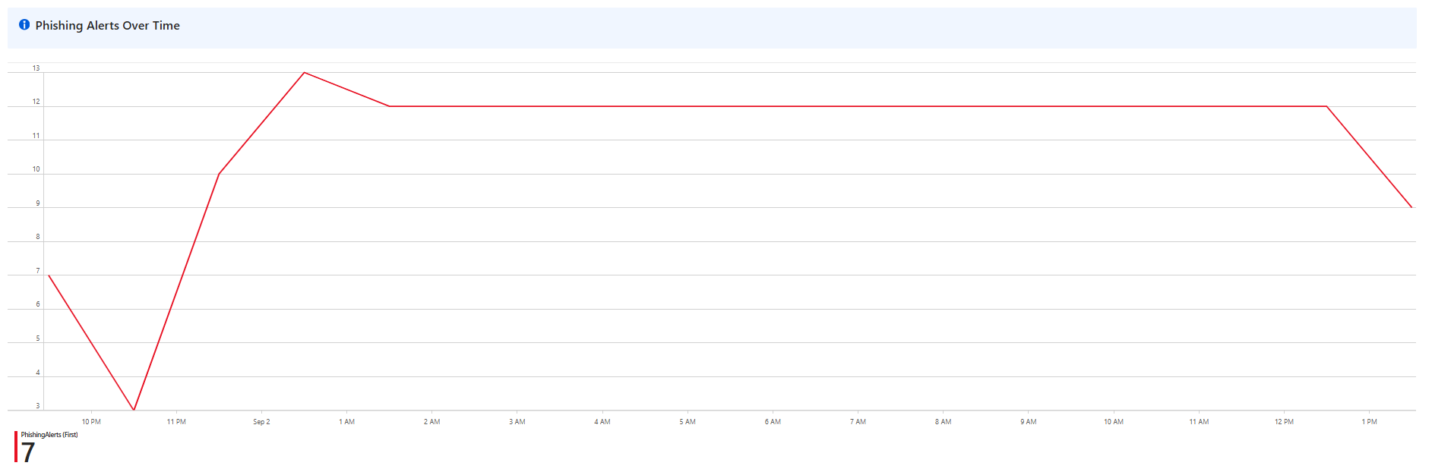

Detailed Phishing Alerts and Investigation
// Look inside the SecurityAlert table
SecurityAlert
| where AlertName contains "Phish" // Only take alerts where the name contains the word "Phish"
| project TimeGenerated, AlertName, ProviderName, tostring(Entities) // Select only useful fields: time of alert, alert name, provider, and entities (like users, IPs, devices)
| order by TimeGenerated desc // Order results so the most recent alerts appear at the top

